|  |  |
| --- | --- |
|  | **Qatar University**  **College of Engineering**  **Department of Computer Science and Engineering** |

**Fall 2023**

**CMPS451**

**Database Management Systems**

**Course Project Report**

**phase 1**

**Submitted By**

|  |  |  |
| --- | --- | --- |
| **Name** | **QUID** | **Email** |
| Ridhwan Athaullah | 202005171 | [ra2005171@qu.edu.qa](mailto:ra2005171@qu.edu.qa) |
| Muhammad Muhaimin Mahdiyan | 201909592 | [mm1909592@qu.edu.qa](mailto:mm1909592@qu.edu.qa) |
| Mohamad Allaham | 202005872 | [ma2005872@qu.edu.qa](mailto:ma2005872@qu.edu.qa) |

|  |
| --- |
| **Table of Contents**  **Modification on the EER Diagram:** 3  **Relational Mapping:** 5  **SQL DDL Statements: We chose to work with MySQL as the DBMS.** 7  **Populating Tables:** 9  **Screen shots of the tables with data:** 11  Employee table: 11  Engineer table: 11  Secretary table: 11  Technician table: 11  Trade Union table: 11  Hourly Employee: 12  Salaried Employee: 12  Project table: 12 |

# **Modification on the EER Diagram:**

From the previous phase (phase 0), we have chosen the following diagram (Company Schema):

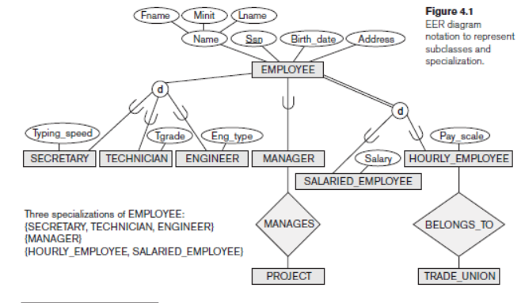

 We have decided to add some **attributes** and **a relationship** in order to enhance the EER diagram.

* **Introduced a new relationship:**

We have decided to include a relationship named (**Manage_Employee**) to the EER diagram:

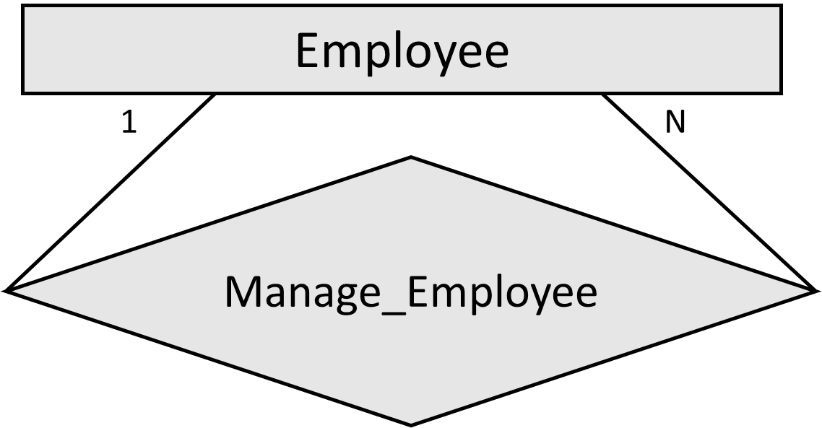

The above relationship is a 1 to N (Many) relationship i.e., One **Manager** Manages Many **Employees** and Many **Employees** are Managed by One **Manager**. Adding a "Manage_Employee" relationship to the Employee table can be beneficial for representing a clearer hierarchical relationship between Manger and Employee and to add further functionality to the Manager Table.

* **Entities and their suggested attributes:**

**Employee:**

* Replace "Birth_date" with "DOB". For simpler query writing.
* Add "PhoneNo" for the employee's contact number.
* Include "Gender" to specify the employee's gender.
* Introduce "HireDate" to track the employee's hire date.
* Include "PayType" to distinguish between Salaried and Hourly employees.
* Add a "Manager" boolean field to indicate if the employee is a manager.
* Create a "ManagerSSN" attribute to establish the relationship (Manage_Employee) between Employee and Manager.

**Technician:**

* Decided "Tgrade" to specify the grade or level of the technician within the organization or department (e.g., grade **1**, **2**, or **3** corresponding to the following: **1.** Entry-Level Technician, **2.** Junior Technician, **3.** Senior Technician).

**Trade_Union:**

* Add "UnionID" as a unique identifier for the trade union.
* Include "UnionName" to store the official name of the trade union.
* Introduce "UnionAddress" to capture the union's physical address.

**Project:**

* Include "ProjectNo" as a unique identifier for projects.
* Add "ProjectName" to store the name of each project.
* Include "Description" to provide a brief project description.
* Introduce "ProjectLoc" to specify the location of each project.
* Add "ManagedBy" to establish a relationship with the Manager entity.

**Hourly_Employee:**

* Include "HoursWorked" to record the number of hours worked per week by the hourly employee.

# **Relational Mapping:**

After finalizing the EER diagram we started mapping it to a relational schema. Because our EER diagram has many specializations, we had multiple possible options to choose how to map the three specializations. However, we have settled on the first option “**Option-A**”. The below figures are the 3 relational schema options:

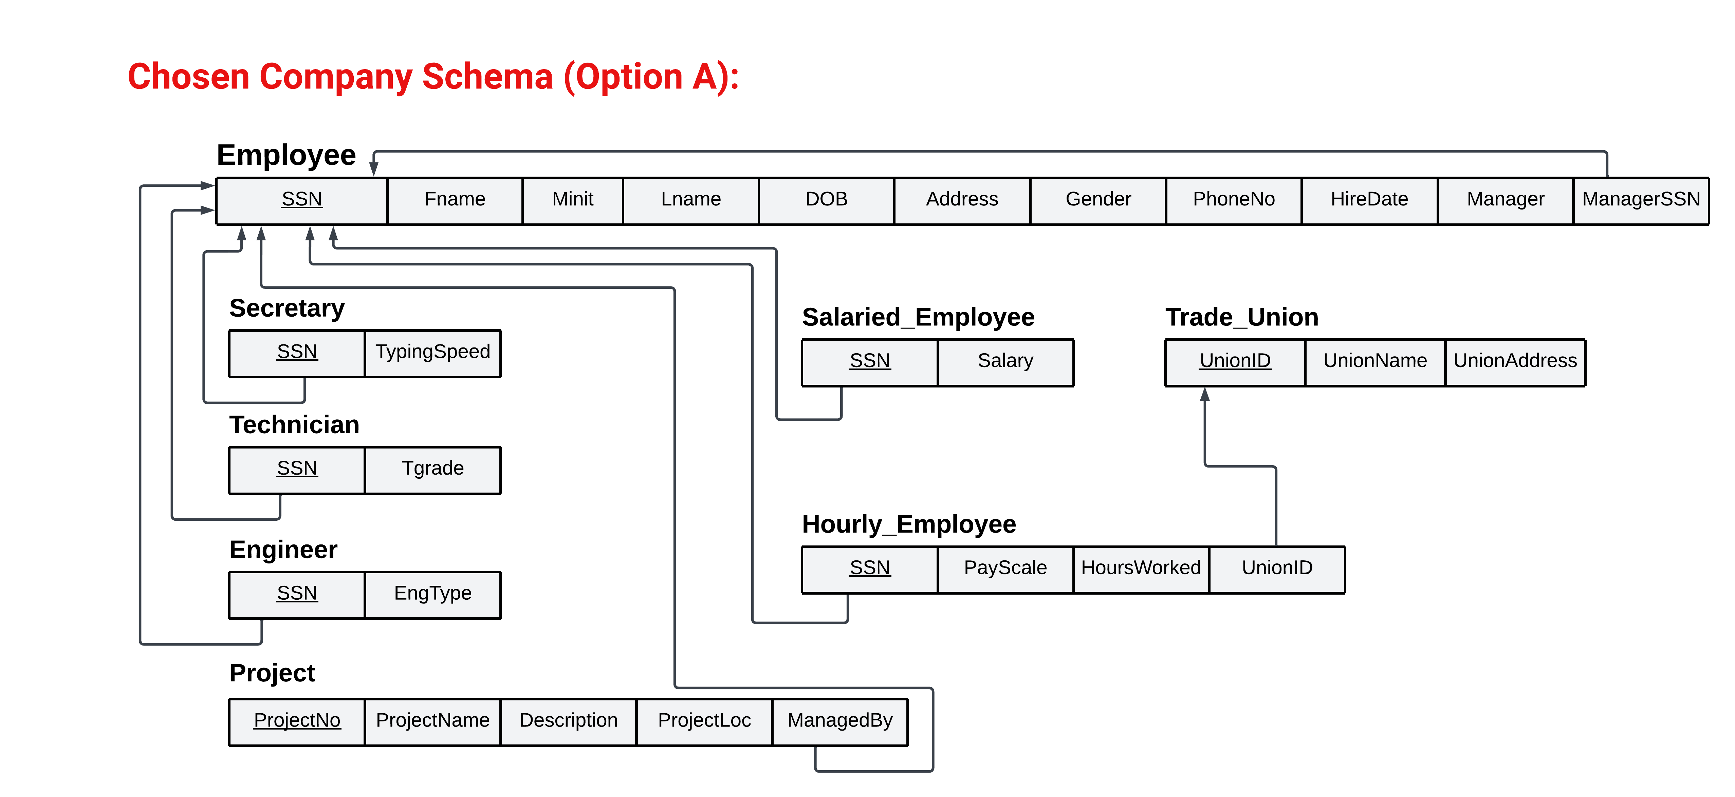

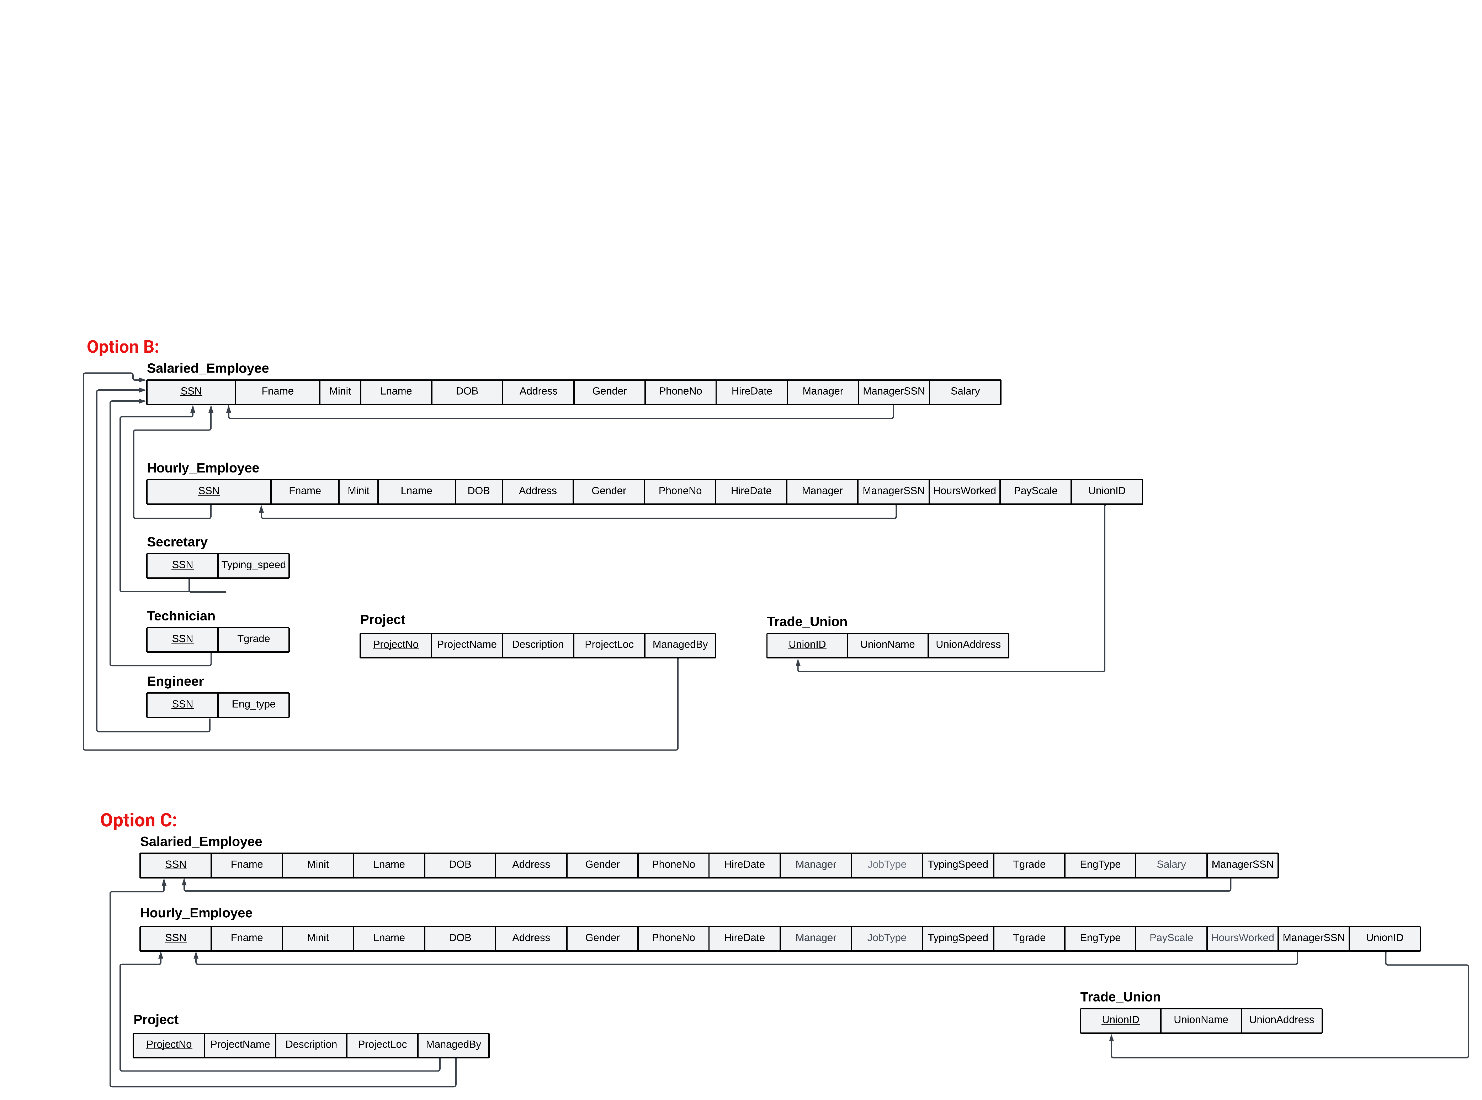

**For Option-A:**

We used the mapping technique known as “Multiple Relations-Superclass and Subclasses” for the specializations: (Employe: {Secretary, Technician, Engineer} and Employee: {Hourly_Employee, Salaried_Employee}) but since the Manager subclass does not have many attributes, we decided to add a boolean flag to indicate whether the employee is a manager or not. The “Multiple Relations-Superclass and subclasses” means map all the entities subclasses or superclass into separate tables while the subclass tables have a foreign key that references the primary key of the superclass table.

**For Option-B:**

We used the mapping technique known as “Multiple Relations-Subclass relations only” for Hourly_Employee and Salaried_Employee. We used a boolean flag for Manager and separate tables for Secretary, Technician, and Engineer like in Option-A. “Multiple Relations-Subclass relations only” means map the subclasses only and include their superclass’s attributes in each of them. This technique is best for total (double line) and disjoint (d) specializations, which is the case for Hourly and Salaried Employee in the EER diagram above.

**For Option-C:**

We used the same mapping technique for Hourly and Salaried Employee from Option-B but we combined the Secretary, Technician, and Engineer into the 2 tables (Hourly_Employee and Salaried_Employee) only differentiating between the 3 by an indicator attribute “JobType” this technique is known as “Single relation with one type attribute”.

**Although we had three options, Option-A was chosen for the following reasons:**

* **Minimizing NULL Values:** Mapping the 5 entities (Secretary, Technician, Engineer, Hourly_Employee, and Salaried_Employee) into separate tables will help in avoiding unnecessary null values. For example, Option-C the Hourly_Employee will have Tgrade and EngType as NULL in case the Employee is a Secretary and the same situation if the Employee is an Engineer but with TypingSpeed having NULL value. Option-A also leads to reduced data redundancy and storage efficiency. Each table contains only the attributes relevant to that entity type, minimizing NULL values and reducing wasted storage space.
* **Simplifying Querying:** When querying the database, Option-A leads to simpler SQL queries. We can work with tables that directly represent the entity types we are interested in, making it easier to retrieve and manipulate their data.
* **Clarity:** Option-A provides a clearer separation between the superclass and its subclasses, which can enhance the overall clarity and readability of the database schema. Each entity has its dedicated table to make it easier to understand the relationships and attributes associated with each of them.
* **Maintenance:** Option-A helps in making the maintenance of the database easier because changes to one entity type (e.g., adding new attributes or relationships) would not directly impact other entities. For example, in Option-B or Option-C if we needed to modify Employee table to add/remove attributes, we would have to modify both tables Hourly_Employee and Salaried_Emloyee which is more time consuming than in Option-A.

# **SQL DDL Statements: We chose to work with MySQL as the DBMS.**

# Creating Employee **Table**

**CREATE** **TABLE** Employee **(**

SSN VARCHAR**(**9**)** **PRIMARY** **KEY,**

Fname VARCHAR**(**50**)** **NOT** **NULL,**

Minit CHAR**(**1**),**

Lname VARCHAR**(**50**)** **NOT** **NULL,**

DOB DATE **NOT** **NULL,**

Address VARCHAR**(**255**),**

Gender ENUM**(**'Male'**,** 'Female'**),**

PhoneNo VARCHAR**(**15**),**

HireDate DATE**,**

Manager BOOLEAN**,**

ManagerSSN VARCHAR**(**9**),**

**FOREIGN** **KEY** **(**ManagerSSN**)** **REFERENCES** Employee**(**SSN**)**

**);**

# Creating Secretary **Table**

**CREATE** **TABLE** Secretary **(**

SSN VARCHAR**(**9**)** **PRIMARY** **KEY,**

TypingSpeed INT**,**

**FOREIGN** **KEY** **(**SSN**)** **REFERENCES** Employee**(**SSN**)**

**);**

# Creating Technician **Table**

**CREATE** **TABLE** Technician **(**

SSN VARCHAR**(**9**)** **PRIMARY** **KEY,**

Tgrade ENUM**(**'1'**,** '2'**,** '3'**),**

**FOREIGN** **KEY** **(**SSN**)** **REFERENCES** Employee**(**SSN**)**

**);**

# Creating Engineer **Table**

**CREATE** **TABLE** Engineer **(**

SSN VARCHAR**(**9**)** **PRIMARY** **KEY,**

EngType VARCHAR**(**50**),**

**FOREIGN** **KEY** **(**SSN**)** **REFERENCES** Employee**(**SSN**)**

**);**

# Creating Salaried_Employee **Table**

**CREATE** **TABLE** Salaried_Employee **(**

SSN VARCHAR**(**9**)** **PRIMARY** **KEY,**

Salary DECIMAL**(**10**,** 2**),**

**FOREIGN** **KEY** **(**SSN**)** **REFERENCES** Employee**(**SSN**)**

**);**

# Creating Trade_Union **Table**

**CREATE** **TABLE** Trade_Union **(**

UnionID VARCHAR**(**10**)** **PRIMARY** **KEY,**

UnionName VARCHAR**(**255**)** **NOT** **NULL,**

UnionAddress VARCHAR**(**255**)**

**);**

# Creating Hourly_Employee **Table**

**CREATE** **TABLE** Hourly_Employee **(**

SSN VARCHAR**(**9**)** **PRIMARY** **KEY,**

PayScale DECIMAL**(**8**,** 2**)** **NOT** **NULL,**

HoursWorked INT**,**

UnionID VARCHAR**(**10**),**

**FOREIGN** **KEY** **(**SSN**)** **REFERENCES** Employee**(**SSN**),**

**FOREIGN** **KEY** **(**UnionID**)** **REFERENCES** Trade_Union**(**UnionID**)**

**);**

# Creating Project **Table**

**CREATE** **TABLE** Project **(**

ProjectNo INT **PRIMARY** **KEY,**

ProjectName VARCHAR**(**255**)** **NOT** **NULL,**

Description TEXT**,**

ProjectLoc VARCHAR**(**255**)** **NOT** **NULL,**

ManagedBy VARCHAR**(**9**),**

**FOREIGN** **KEY** **(**ManagedBy**)** **REFERENCES** Employee**(**SSN**)**

**);**

# **Populating Tables:**

-- Insert sample data to employee

**INSERT** **INTO** Employee **(**SSN**,** Fname**,** Minit**,** Lname**,** DOB**,** Address**,** Gender**,** PhoneNo**,** HireDate**,** Manager**,** ManagerSSN**)**

**VALUES**

**(**'1234'**,** 'Mohammed'**,** 'A'**,** 'Ali'**,** '1990-05-15'**,** '123 Main St'**,** 'Male'**,** '555-123-4567'**,** '2015-03-20'**,** **FALSE,** **NULL),**

**(**'2345'**,** 'Lea'**,** 'R'**,** 'Garcia'**,** '1988-09-10'**,** '456 Elm St'**,** 'Female'**,** '555-234-5678'**,** '2016-02-12'**,** **FALSE,** **NULL),**

**(**'5678'**,** 'Carlos'**,** 'J'**,** 'Lopez'**,** '1991-03-12'**,** '678 Cedar St'**,** 'Male'**,** '555-567-8901'**,** '2016-09-30'**,** **TRUE,** **NULL),**

**(**'6789'**,** 'Lina'**,** 'S'**,** 'Martinez'**,** '1995-11-05'**,** '789 Birch St'**,** 'Female'**,** '555-678-9012'**,** '2019-06-22'**,** **TRUE,** **NULL),**

**(**'3456'**,** 'James'**,** 'M'**,** 'Rodriguez'**,** '1992-12-02'**,** '789 Oak St'**,** 'Male'**,** '555-345-6789'**,** '2017-08-05'**,** **FALSE,** '6789'**),**

**(**'4567'**,** 'Sara'**,** 'L'**,** 'Khan'**,** '1993-07-21'**,** '567 Pine St'**,** 'Female'**,** '555-456-7890'**,** '2018-04-15'**,** **FALSE,** '6789'**);**

-- Insert sample data into Secretary table

**INSERT** **INTO** Secretary **(**SSN**,** TypingSpeed**)**

**VALUES**

**(**'1234'**,** 60**),**

**(**'2345'**,** 70**);**

-- Insert sample data into Technician table

**INSERT** **INTO** Technician **(**SSN**,** Tgrade**)**

**VALUES**

**(**'3456'**,** 2**),**

**(**'4567'**,** 3**);**

-- Insert sample data into Engineer table

**INSERT** **INTO** Engineer **(**SSN**,** EngType**)**

**VALUES**

**(**'5678'**,** 'Software'**),**

**(**'6789'**,** 'Civil'**);**

-- Insert sample data into Salaried_Employee table

**INSERT** **INTO** Salaried_Employee **(**SSN**,** Salary**)**

**VALUES**

**(**'1234'**,** 60000.00**),**

**(**'2345'**,** 55000.00**);**

-- Insert sample data into Trade_Union table

**INSERT** **INTO** Trade_Union **(**UnionID**,** UnionName**,** UnionAddress**)**

**VALUES**

**(**'UNION001'**,** 'Engineering Union'**,** '123 Union St'**),**

**(**'UNION002'**,** 'Labor Union'**,** '456 Labor Ave'**),**

**(**'UNION003'**,** 'Technical Workers Union'**,** '789 Tech Rd'**),**

**(**'UNION004'**,** 'Healthcare Workers Union'**,** '456 Health Rd'**),**

**(**'UNION005'**,** 'Teachers Union'**,** '789 Education Ave'**),**

**(**'UNION006'**,** 'Transport Workers Union'**,** '123 Transport Blvd'**);**

-- Insert sample data into Hourly_Employee table

**INSERT** **INTO** Hourly_Employee **(**SSN**,** PayScale**,** HoursWorked**,** UnionID**)**

**VALUES**

**(**'3456'**,** 16.00**,** 155**,** 'UNION001'**),**

**(**'4567'**,** 13.50**,** 175**,** 'UNION004'**),**

**(**'5678'**,** 14.25**,** 160**,** 'UNION005'**),**

**(**'6789'**,** 14.75**,** 155**,** 'UNION006'**);**

-- Insert sample data into Project table

**INSERT** **INTO** Project **(**ProjectNo**,** ProjectName**,** Description**,** ProjectLoc**,** ManagedBy**)**

**VALUES**

**(**101**,** 'Building Construction'**,** 'Construction of a new office building'**,** 'City Center'**,** '6789'**),**

**(**102**,** 'Software Development'**,** 'Development of a new software application'**,** 'Tech Park'**,** '5678'**);**

# **Screen shots of the tables with data:**

## Employee table:

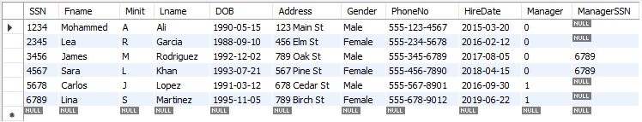

## Engineer table:

## Secretary table:

## Technician table:

## Trade Union table:

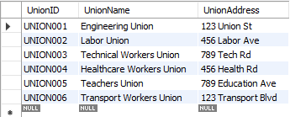

## Hourly Employee:

## Salaried Employee:

## Project table:

